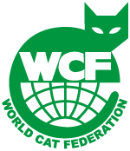
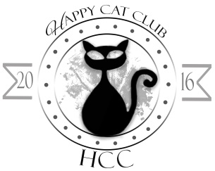
CERTIFICATE
♕ KLUBBMÄSTERSKAP ♕
ARBOGA ║ MAY 24” ║ 2017

Cats name: Kentuckygårdens katt No12
Ras/Rasse/Race: Brittish shorthair
Färg/Farbe/Colour: Colourpoint EMS code: 25452546
Kön/Geschlecht/Sex: Female Född/Geboren/Born: 2015-08-16
Klass/Klasse/Class: 15 (6-10 month)
BEDÖMNING ║ RICHTERBERICHT ║ JUDGEMENT
Kropp/Körper/Body___________________________________________________________
Huvud/Kopf/Head____________________________________________________________
Ögon/Augen/Eyes____________________________________________________________
Öron/Ohren/Ears_____________________________________________________________
Päls/Fell/Coat________________________________________________________________
Svans/Schwanz/Tail___________________________________________________________
Kondition/Condition___________________________________________________________
………………………………………………………………..……. ……………………….…………………….…………
BEDÖMNING/BEWERTUNG/QUALIFICATION Domare/Richter/Judge
Secretary’s Notes:

